Large Roses
Class 1: 3 exhibition blooms 3 vases
Any cultivar or cultivars
Class 2: 3 decorative blooms 1 vase
Any cultivar or cultivars
Class 3: 1 fully open bloom 1 vase

Class 4: 1 rose in 3 stages of development 1 vase
One cultivar
Class 5: 1 large stem of roses 1 vase

Class 6: 2 small stems of roses 1 vase
Any cultivar or cultivars
Class 7: 1 vase of HT type blooms 1 vase
Any cultivar or cultivars – judged for frontal effect

Miniature Roses

Class 8: 3 exhibition type blooms 1 vase
3 distinct cultivars
Class 9: 3 decorative blooms 1 vase
3 distinct cultivars
Class 10: 3 small stems 1 vase
3 distinct cultivars
Class 11: A rose in 3 stages of development 1 vase

Class 12: A bloom floating in a wine glass
Wine glass supplied

25th Anniversary Special Award
Vase of English Roses
Exhibitors to supply own vase

Kath Henry Challenge Trophy
Surplus roses placed in a bucket
Bucket supplied (no oasis allowed)

Canterbury 200 Trophy for Surplus Miniature Roses
Surplus miniature type roses
Small bucket supplied

40th Anniversary Trophy
An outstanding exhibit in sections 1 to 12

Non Ranfurly Competition
Scenic Westland
Depicting Westland at its best, the mountains, rivers, bush, beaches, sunrise, sunsets
Roses with other flowers and foliage – accessories allowed
1 accessory will be supplied and MUST be used in the arrangement
(75cm x 75cm)

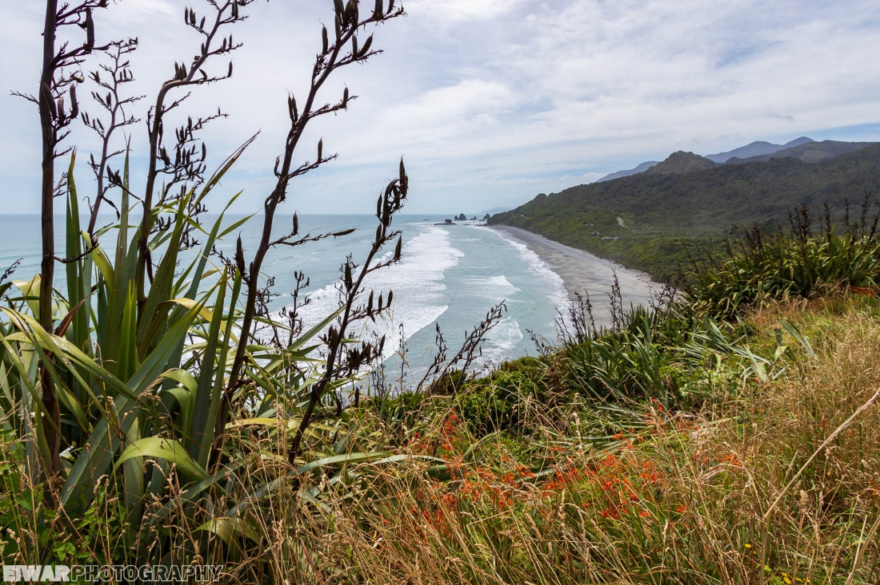

Programme

Friday
5:00pm Hall opens for drop off of roses only

7:00pm Registration and get together with light refreshments

Saturday
6:30am hall opens for staging
Light breakfast available

10:00 am Staging to be complete

10:00 am – 12:30pm Free time

12:45 pm Follow the Leader Garden Ramble
Take own cars – leave hall at 12:45 pm sharp

1:00pm Hall open to public

4:00 pm Show closes

6:30pm Get together before dinner - Trinity Centre
7:00pm Dinner at Trinity Centre

Sunday
09:30 Morning tea farewell at Marg and Stan’s garden
Hyde Park
668 Taylorville Road
Taylorville

Attractions within easy commute from hall
Monteiths Brewery
Art Gallery
Mitre 10 Garden Centre and Cafe
Town Square
Westland Rose Society presents

Roses in Scenicland

Ranfurly Rose 2020

7th – 9th February

Trinity Centre
Tainui Street
Greymouth

Hall opens for exhibitors at 6:30am. Staging must be completes by 10:00
Sponsored by: Fulton Hogan

